AZ 104 – Trainning

**STORAGE ACCOUNT**

Data Lake Storage Gen2

The Data Lake Storage Gen2 hierarchical namespace accelerates big data analytics workloads and enables file-level access control lists (ACLs).Learn more

* Blob Storage
  + Network File Storage (NFS) to mount drives to VMs
  + Access Tier: Hot and Cold
* Azure Files
  + File shares
* Tables and Queues
  + ???
* Container
  + ???

* Storage Access Key and Access Key
  + ???

* Storage Explorer

* Log Analytics

**COPY FILES WITH AzCopy**

* You can run it like ".\AzCopy "Source URL" "Destination URL"
* Can copy between azure subscription and storage accounts

**ACCESS TIERS (Storage accounts)**

* You will be charge by access and storage.
* Premium Tier, it has to be selected at the moment of the storage account creation.
  + It has better performance, it is ten times faster that standard for retrieving data.
* Hot Tier (Default option)
  + You will be charge the standard for access and storage.
* Cool Tier
  + You will be charge half for storage BUT double for access, read, write, view.
* Archive Tier
  + 99 More cheaper to store files that Hot tier, but more expensive to read, write and view, usually for backups
  + It can take several hours to retrieve the data depending on the priority of the rehydration.
* You can change your access tier, at your storage account level or even file level.
* 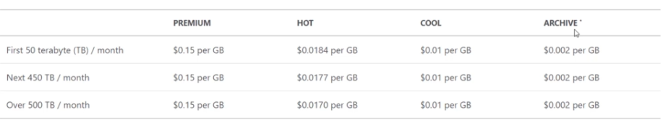

**LIFECYCLE MANAGEMENT (Storage accounts)**

* Example: You want files to be in hot storage for the first 30 days and then you move them to cool storage
* Policies/Rules to move storage between access tiers, defining the time and access tiers.
* 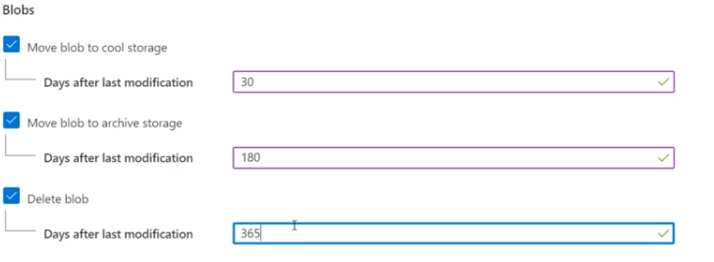

**AZURE AD ACCESS CONTROL FOR STORAGE (Storage accounts)**

* Grant permissions to storage resource to active domain users.
* Storage Account > Access Control (IAM) > Check access >
* Storage Account Contributor to read and write but not to delete

**OBJECT REPLICATION (Storage accounts)**

* Copying data to a different storage account and even to a different region.
* Destination container is read only, this is done by Azure itself.
* You can also create filters.
* Blobchangefeed it indicates the changes done in the storage account

**IMPORT AND EXPORT DATA TO AZURE (Storage accounts)**

**Moving Large Files**